Activity Pack
Session 2

Activity 1:
We have many words for people who come from different countries. We might talk about immigrants, or refugees, or settlers. Can you think of the differences between these terms?

Match the definition to the right word below:

Refugee  un(e) réfugié(e) | Immigrant  un(e) immigré(e) | Settler  un colon

Someone who has moved from one country to live in another part of the world, often one that belongs to their country. | Someone who has fled war, violence, conflict or persecution to find safety in another country. | A person who has come into a foreign country in order to live there.

Activity 2a: Les sentiments

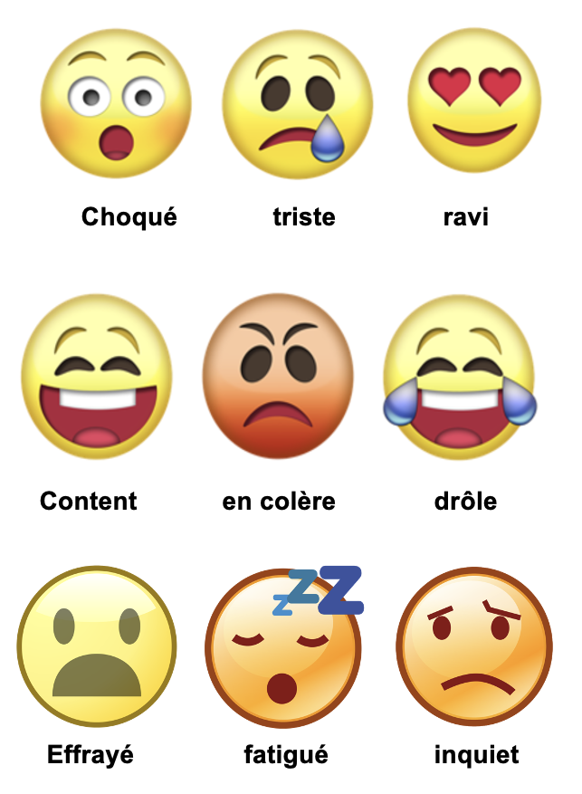

être | To be
Je suis | I am
Tu es | You are
Il est | He is
Elle est | She is
Nous sommes | We are
Vous êtes | You are (plural or formal)
Ils sont | They are
Elles sont | They are (women only)

Using this French emoji chart, pick the emoji responses for each question:
1. How do you think Jeanne’s great-grandfather felt about leaving France?
2. How do you think Jeanne’s grandfather felt about being given farmland in Algeria?
3. How would you feel?

Activity 2b:
Using your French emoji chart again, pick the emoji responses for each question:
1. How do you think the Arabs living in Algeria felt about the French coming?
2. How do you think local Arabs felt about working for Jeanne’s great-grandfather?

New vocabulary
content  triste | Happy  Sad

