Activity Pack
Session 1

Activity 1: Carte de la région
Fill in the correct French place names from the box on the map below. You will not need to use all of the names – there are some red herrings!

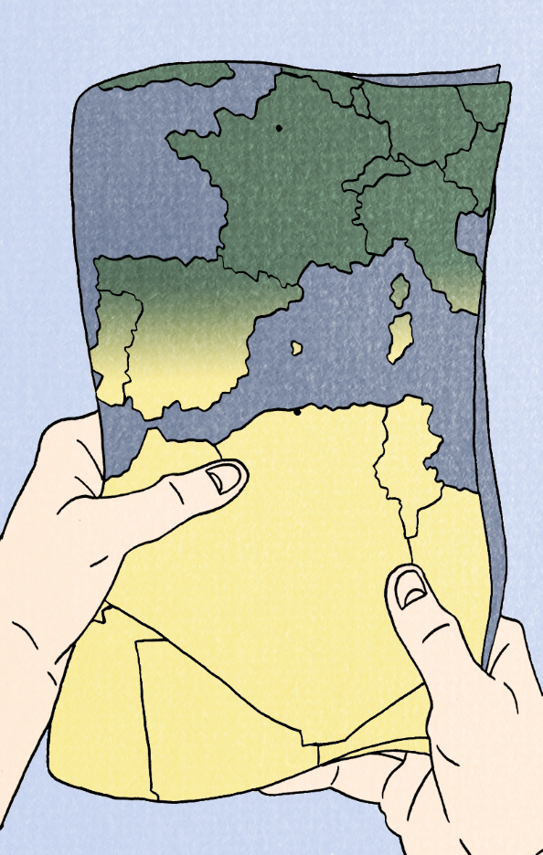

Algérie Espagne Allemagne Irlande Madrid
France Italie Tunisie Alger la Mer Méditerranée
Mauritanie Maroc Libye Paris Portugal
Écosse Grèce Rome la Mer Atlantique

Activity 2a: What’s in my valise?
As you have seen in the comic, Jeanne and her family need to pack their valises very quickly to leave the country. They don’t have time or space to pack everything.

I will call out the items in my valise in French, see how many you can identify! I will take the item out only when you correctly identify it!

Items I heard:

Activity 2b: Qu’est-ce que tu mets dans ta valise ?

What would you put in your suitcase? Jeanne had to pack her suitcase very quickly when they had to leave Algeria. If you were in that situation, what would you pack?

Activity: Fill the suitcase below with pictures and label them in French. Be prepared to explain why you’ve chosen each of the items!

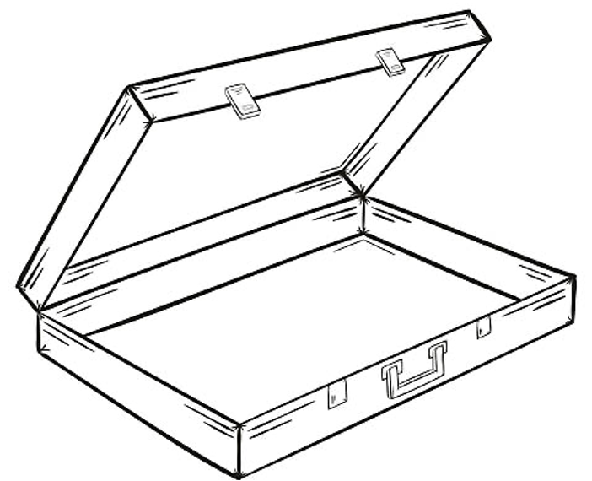

New vocabulary
La valise  La carte | Suitcase  map

