Fiche de Lecture

The fiche de lecture is a way of keeping notes on Les Pieds tanqués that well help you remember what you have learnt and will be an invaluable source for writing an essay on the play.
Les Pieds tanqués
Director

Genre
Plot summary

Key Characters
Setting and time period
Key themes
Session 6
Pp9-18
Key moments and quotations
Session 7
Key moments and quotations
Session 8
Key moments and quotations
Session 9
Key moments and quotations
Session 10
Key moments and quotations
Session 11
Key moments and quotations

 | Loule
Image
Name  Origin/ethnicity | Loule
Clothing
Accent
Social status
Relation to France
Relation to Algeria
Angry at who and when? Why?
Key quotations

 | Yaya
Image | 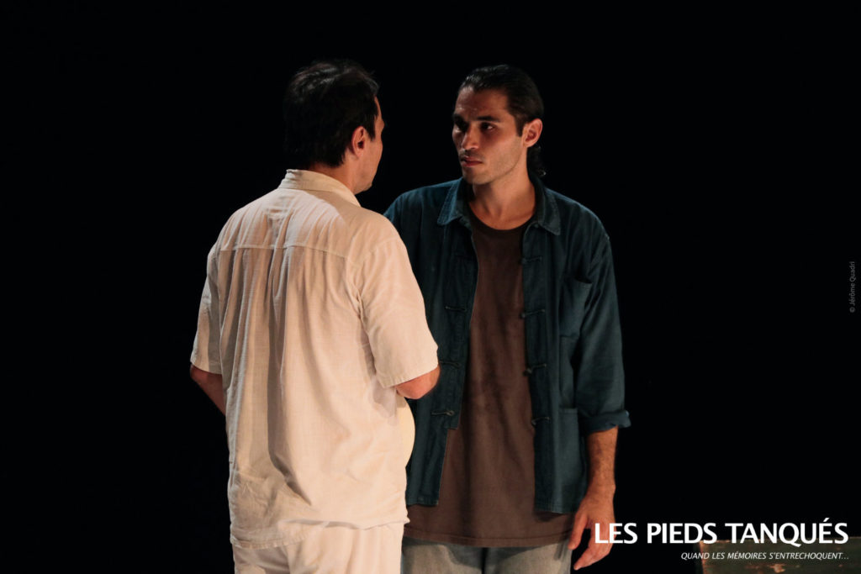
Name  Origin/ethnicity | Yaya
Clothing
Accent
Social status
Relation to France
Relation to Algeria
Angry at who and when? Why?
Key quotations

 | Zé
Image
Name  Origin/ethnicity | Zé
Clothing
Accent
Social status
Relation to France
Relation to Algeria
Angry at who and when? Why?
Key quotations

 | Monsieur Blanc
Image
Name  Origin/ethnicity | Monsieur Blanc
Clothing
Accent
Social status
Relation to France
Relation to Algeria
Angry at who and when? Why?
Key quotations

