Activity Pack
Session 5
Activity 1: Fais ta valise !

Packing suitcase role play
- Get into groups of 2-3
- One pupil will be Jeanne and 1-2 will be her parent(s)
- Parents: ask Jeanne what she will put in her suitcase. You can give ideas for what she can include from this activity sheet and use gestures / charades to help your ‘Jeanne’ understand!
- Jeanne: say what you do and don’t want in your suitcase. You can use this activity sheet for possible answers and use gestures / charades to help your ‘parents’ understand.
What next? Change roles as you role play

Parents
Est-ce que tu veux… | Do you want…
Tu veux …

Veux-tu…

un livre | a book
un jouet | a toy
de l’argent | some money
un sandwich | a sandwich
un manteau | a coat
un pantalon | trousers
des medicaments | some medicine
le chien | the dog

Jeanne
Oui, je veux… | Yes, I want…
Non, je ne veux pas… | No, I do not want…
Je ne sais pas | I don’t know

un livre | a book
un jouet | a toy
de l’argent | some money
un sandwich | a sandwich
un manteau | a coat
un pantalon | trousers
des medicaments | some medicine
le chien | the dog
Activity 2: Les Sentiments

Emotions roleplay
- Get into groups of 2-4
- One pupil will be Jeanne’s grandfather and 1-3 will be his worker(s) on the farm.
- Jeanne’s grandfather: do a charade for your emotions when you think about the farm that the government has given you and your local workers. The others will guess which emotion it is (in French)!
- Workers: do charades to show how you feel working hard on the farm for Jeanne’s family on the land you used to own. The others will guess which emotion it is (in French)!
- You can use the activity sheet vocabulary to help!
What next? Change roles as you role play

The grandfather / Grand-père
Je suis… | I am… + emotions from below
J’aime la ferme | I like the farm
Je n’aime pas la ferme | I do not like the farm
Vous êtes comme ma famille | You are like my family

Les travailleurs / Workers
Je suis… | I am… + emotions from below
J’aime la ferme | I like the farm
Je n’aime pas la ferme | I do not like the farm
Vous êtes comme ma famille | You are like my family

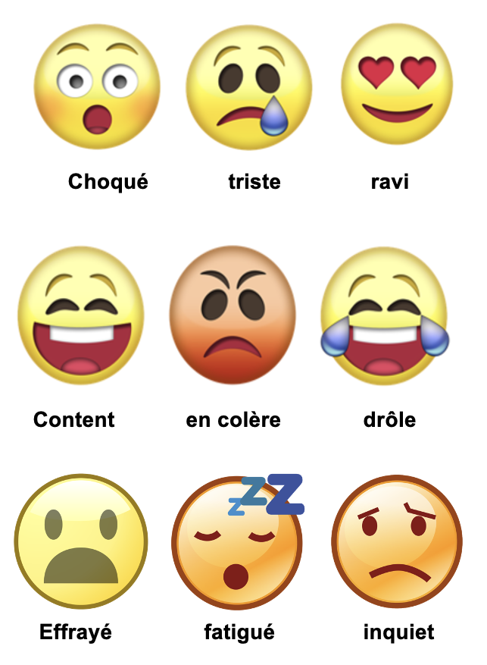
Activity 3: L’Avenir

Omar grows up and moves to France to find work. What will happen next?
- Using ideas from your activity sheet, imagine what you think will happen next now that Omar has arrived in France.
- Think about how he will be treated and how his life may change.
- When ready, you will act out your panels in groups. They will guess which answers you have chosen in French from your charades.
- The ideas on the next slide and on your activity sheet can be used to help:

 | Option 1 | Option 2 | Option 3
Le temps en France  The French weather | Il fait chaud  It is hot | Il pleut  It rains | Il fait froid  It is cold
Chez moi  My home | J’ai un petit studio  I have a little studio flat | Je partage un appartement avec deux autres  I share an apartment with two others | J’habite chez des amis  I live with friends
Le travail  Work | Je travaille au marché  I work in the market | Je cherche un travail  I am looking for a job | Je travaille le soir dans un restaurant  I work evenings in a restaurant
La ville  The city | Est belle  Is beautiful | Est chère  Is expensive | Est grande  Is big
J’aime  I like | La nourriture  The food | Les parcs  The parks | Les monuments  The monuments
Je n’aime pas  I don’t like | Me perdre dans la ville  Getting lost in the city | Me sentir seul  Feeling lonely | Travailler tous les jours  Working everyday
Je veux  I want | Un bon appartement  A good apartment | Des amis  friends | Trouver un bon travail  To find a good job

